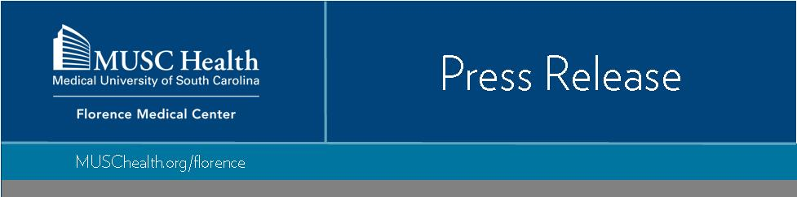
FOR IMMEDIATE RELEASE
Contact:
John Russell
MUSC Health Florence Division
Marketing Manager
843-674-2953
russeljo@musc.edu

MUSC Health Florence and Marion Medical Centers announce
DAISY Award recipients

FLORENCE — MUSC Health Florence and Marion Medical Centers would like to announce the most recent DAISY honorees. The DAISY award is given to a nurse whose job performance exemplifies the mission, vision and values of MUSC Health. The recipient must also keep a consistent focus on meeting patient-family goals, collaborate with the healthcare team to meet patients’ needs, use critical thinking to deliver extraordinary patient care, and demonstrate a caring attitude, as well as professionalism in the workplace during all situations, according to the hospital announcement.
MUSC Health Florence Medical Center recently named 8th floor MedSurg registered nurse, Teresa Jenkins, as the latest recipient of the DAISY Award for nursing. She has spent 37 years in nursing. “As a little girl I always had compassion for others and put their needs before my own,” Jenkins said.
She was nominated by patient, Bart Meyers, and Linda Meyers, and described Jenkins as, “present every day with a smile on her face and a calm patient spirit. I watched her handle so many issues at one time, it was amazing. She never got frustrated or impatient. She is here early and stays late at the end of her shift to make sure her patients have what they need. She is thoughtful and thorough.”

Jenkins’ co-workers describe her as, “dedicated, kind, respectful to patients and staff alike, having a passion for nursing, compassionate, thorough and knowledgeable.”

MUSC Health Marion Medical Center recently also named Licensed Practical Nurse Shenna Davis, as the latest recipient of the DAISY Award for nursing. She was a Certified Nursing Assistant for 16 years, before going back to school the become Licensed Practical Nurse for the past eight years. “I can really say I’ve learned so much on this journey. I have always loved nursing and helping people get better,” Davis said.

A patient under her care said, “The first thing you notice about Shenna is her smile. She was so patient and kind to our entire family. She was compassionate and understanding. She never made us feel like we were bothering her and always took the time to answer our questions. We will always remember her smile and all the kindness she showed when we needed her the most. Shenna is one-of-a-kind.”

Davis’ co-workers describe her as, “a team player who does whatever she can to support the needs of the patients and the needs of the team and an exemplary employee.”

The DAISY Foundation is a not-for-profit organization established in memory of J. Patrick Barnes by members of his family. The hospital announcement said that “Patrick died at the age of 33 in late 1999 from complications of Idiopathic Thrombocytopenic Purpura (ITP), a little known but not uncommon auto-immune disease. (DAISY is an acronym for Diseases Attacking the Immune System.) The care Patrick and his family received from nurses while he was ill inspired this unique means of thanking nurses for making a profound difference in the lives of their patients and patient families.”
Nurses can be nominated by patients, families, and colleagues. Recipients of the DAISY Award are chosen quarterly by the DAISY committees at MUSC Health Florence Medical Center and MUSC Health Marion Medical Center.
About MUSC

Founded in 1824 in Charleston, MUSC is the state’s only comprehensive academic health system, with a unique mission to preserve and optimize human life in South Carolina through education, research and patientcare. Each year, MUSC educates more than 3,200 students in six colleges – Dental Medicine, Graduate Studies,Health Professions, Medicine, Nursing and Pharmacy – and trains more than 900 residents and fellows in its health system. MUSC brought in more than $298 million in research funds in fiscal year 2022, leading the stateoverall in research funding. MUSC also leads the state in federal and National Institutes of Health funding, withmore than $220 million. For information on academic programs, visit musc.edu.As the health care system of the Medical University of South Carolina, MUSC Health is dedicated to delivering the highest-quality and safest patient care while educating and training generations of outstanding health careproviders and leaders to serve the people of South Carolina and beyond. Patient care is provided at 16 hospitals (includes owned and equity stake), with approximately 2,700 beds and four additional hospital locations in development; more than 350 telehealth sites and connectivity to patients’ homes; and nearly 750 care locations situated in all regions of South Carolina. In 2022, for the eighth consecutive year, U.S. News & World Report named MUSC Health University Medical Center in Charleston the No. 1 hospital in South Carolina. To learn more about clinical patient services, visit muschealth.org.MUSC has a total enterprise annual operating budget of $5.1 billion. The nearly 26,000 MUSC family members include world-class faculty, physicians, specialty providers, scientists, students, affiliates and care team members who deliver groundbreaking education, research, and patient care.
# # #

